Welcome to 7th grade 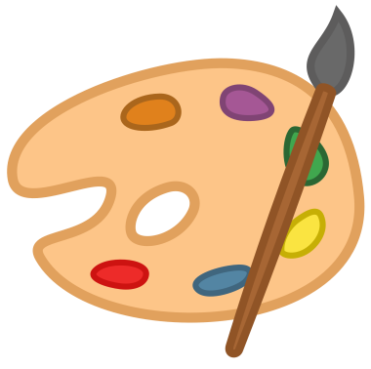
MSVPA INTEGRATED VISUAL ART CLASS (2017-2018 class syllabus)
••••••••••••••••••••••••••••••••••••••••••••••••••••••••••••••••••••••••••••••••••
Mrs. Nichols • Room #111 • bnichols@wcskids.net
Weebly: remind:
In this class we will:
- Learn about and create art based on the 7th grade social studies curriculum
- Learn about various art techniques and skills and how to use them in the artwork you create
- Learn how to use various art materials
- Learn how to think about, analyze and describe art
- Make connections to and deepen understanding about art within society, culture and history
Class assignments and grading:  Assignments will mainly be project based. Occasionally a quiz or test will be given, as well as a writing assignment.  Grading will be in points and in accordance to the school district grading policy. | To receive the most points possible you will be expected to participate, complete assignments, make a strong effort, demonstrate that you care about your work, follow directions, and work to develop your art skills and style.

What to bring to class each day: Yourself. Be on time and ready to learn. Most materials will be provided. However, sometimes I will ask you to bring in a special item such as a jar. Please do this if I ask.
A list of things you probably already know, but just in case you need a reminder:
- Don’t be tardy.
- Enter the class; put your stuff out of the way; sit in your assigned seat.
- Listen quietly when the teacher addresses the class.
- Clean up after YOURSELF.
- Stay in your seat until the teacher dismisses you. (Don’t pile up at the door for dismissal.)
- Show respect-to everyone at all times.
The cell phone policy for the art room:
Your phone must be put away, UNLESS the teacher asks you to take it out for research or some other purpose.
If you have your phone out without permission, the teacher will hold it until the end of the hour. Repeatedly disregarding the cell phone policy of this class may result in further undesirable consequences.

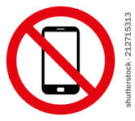
A final note:
Let’s be mindful of our environment. Throw out gross things, but recycle cardboards, paper and plastics (including water bottles) that can be recycled. Useable scraps should be put in the scrap box. Erasable boo boos should be erased. Care should be used when pouring paint, so as not to waste it.
Here’s to a great year of learning, growing, laughter and fun!
I am happy you are here!

